Sprint Report  
Sprint 6 Submission

Submission Date: 16 March 2021

Team A

Gregorson Mahon T00057640

Taylor Peck T00483746

Nicholas Piluso T00586492

Contents

List of tasks for the previous week 3

List of tasks for the coming week 4

Application Server Backlog: 4

Web Site Backlog: 5

Project Management Tool Screenshot 6

Updated Mock-ups or Other Relevant Documents 7

# List of tasks for the previous week

|  |  |
| --- | --- |
| Task Name | Responsible Team Member |
| **Team Meeting for …**   * Team updates & discussion on what needs to happen next | All Team Members |
| **Continue development on web site:**   * Client and server-side validation for creating an account and signing in. * Sign out. * Add a recipient and validation. | Taylor |
| **Continue development on web site:**   * Started working on a universal CSS theme. | Gregorson |
| **Continue development of the Application Server:**   * Calculate which properties are inside which new outages and add a PropertyOutage record to the DB * Retrieve user contact settings & property info from DB for updated/new outages so that informative messages can be created and sent to these users (add DB functionality to AppModelDB.py) * Rename AppModelRetrieveJSON.py to AppController.py and move non-controller functions (json functions, etc) to their own Model files. * Deactivate PropertyOutage records in the DB where power has been restored to a property * Send outage messages in the list ‘*ListOfOutageMessages*’ to the users | Nick |

# List of tasks for the coming week

|  |  |
| --- | --- |
| Task Name | Responsible Team Member |
| **Team Meeting for:**   * ?? | All Team Members |
| **Continue development on web site:**   * Continue work on main page components * Create functionality/page to handle user account locked status. | Taylor |
| **Continue development on web site:**   * Create and implement a universal CSS theme for the pages. * Update database to store property longitude & latitude information * Add functionality to edit properties and recipients to database | Gregorson |
| **Continue development of the Application Server:**   * Perform some much-needed unit, component and release testing for App Server. | Nick |

# Application Server Backlog:

1. Perform unit, component and release testing for App Server. ***(Assigned to Nick March 15th 2021)***
2. Reactivate a PropertyOutage in the DB where power has been lost again - if it was previously restored (use UpdatePropertyOutages in AppModelDB.py) (This is a low-priority item since this case is not expected to occur)

# Web Site Backlog:

* Get property information from database, encode as JSON array, create method to parse and build table on the mainpage (get property information method created). ***(Assigned to Taylor March 15, 2021)***
* Get recipient information and recipient property information from database, encode as JSON arrays, create method to parse and build table on the mainpage (get recipient information method created. Also need to figure out how to represent these, maybe with a sub table). ***(Assigned to Taylor March 15, 2021)***
* Method to insert recipient properties with correct associations between this table and properties and recipients tables.
* Create and implement a universal CSS theme for the pages. (***Assigned to Gregorson March 2nd 2021***)
* Functionality to handle if a user’s account is locked (redirect to a new page?).
* Functionality to edit a property (methods to update the database listings). ***(Assigned to Gregorson March 15th, 2021)***
* Current method of getting user’s address is a bit suspect. Perhaps find a better option and implement it (perhaps Google’s Places API?). Or maybe some sort of validation. Need to discuss this.
* Functionality to edit a recipient (method to update their information in the database). ***(Assigned to Gregorson March 15th, 2021)***
* Functionality to change recipient property notification status (update in database when checking a box in the table).
* Password reset functionality (create dialog, email to user, password reset page, database update methods).
* Reconfigure UI of pages to improve UX (long term goal, somewhat dependent on what we learn in this course).

# Project Management Tool Screenshot

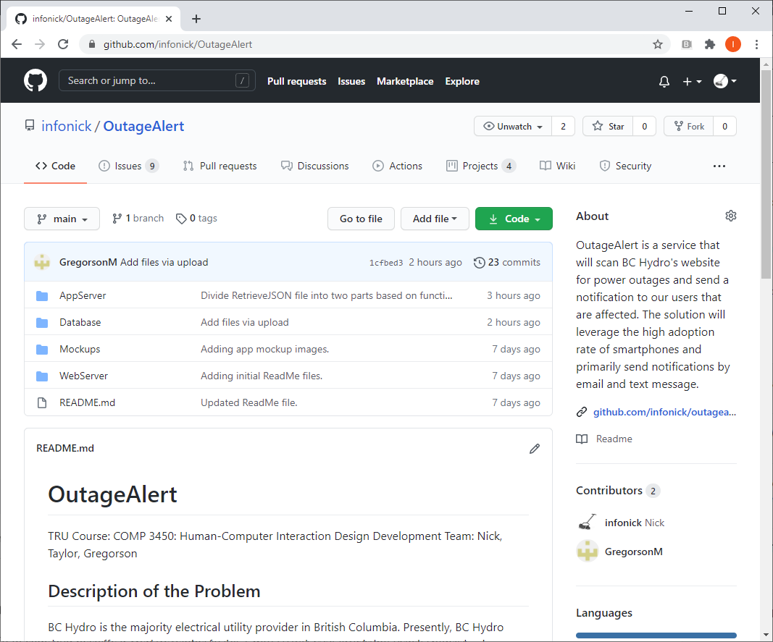

Interested readers may review the GitHub: <https://github.com/infonick/OutageAlert/>

# Updated Mock-ups or Other Relevant Documents

“You can include any other information such as screenshots of your app in progress or mock-ups showing what you plan to do in the coming week.”

